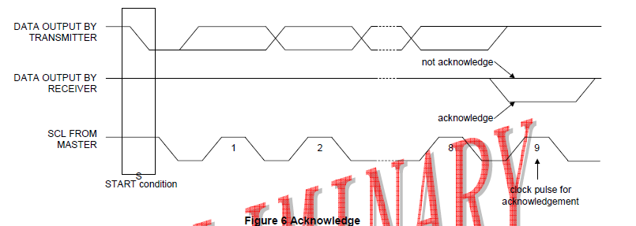
OLED display IIC communication response signal is a clock signal (SCL) in the ninth clock cycles, the serial data (SDA) returns a low level, as a response signal.

